**Capstone Dashboard Report**

**Q1. Top 10 Category wise Sales**

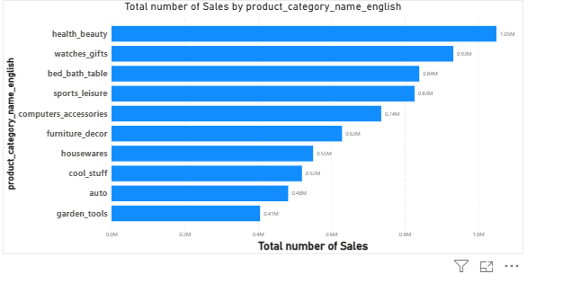

**Q1. Analysis:**

The bar graph titled "Total number of Sales by product_category_name_english" illustrates the sales performance across various product categories.

**Key Observations:**

**Top Performer:** "Health beauty" is the leading product category with the highest sales, reaching 1.05M.

**Strong Sales:** "Watches gifts" and "bed bath table" also demonstrate high sales figures, at 0.93M and 0.84M respectively.

**Mid-Range Categories:** Categories like "sports leisure," "computer accessories," "furniture decor," and "housewares" show moderate sales, ranging from 0.74M down to 0.55M.

**Lower Sales:** "Cool stuff," "auto," and "garden tools" represent the categories with comparatively lower sales, with "garden tools" having the lowest at 0.41M.

**Overall Trend:** The graph visually represents a clear hierarchy of sales performance, with a significant drop-off in sales volume from the top-performing categories to the lower-performing ones.

**Q2. Total number of delayed orders in each category**

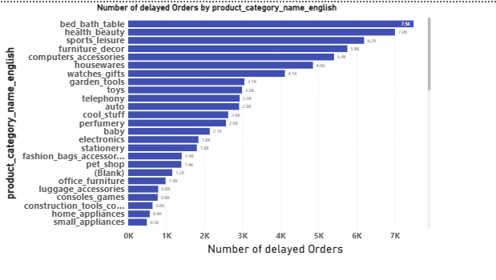This graph, titled "Number of delayed Orders by product_category_name_english," illustrates the distribution of delayed orders across various product categories.

**Key Observations:**

**Highest Delayed Orders:** "Bed_bath table" and "health_beauty" consistently show the highest number of delayed orders, exceeding 6K.

**Significant Delays:** Categories like "sports leisure," "furniture decor," "computers accessories," and "housewares" also demonstrate a substantial number of delayed orders, ranging from approximately 3K to 5K.

**Moderate Delays:** "Watches gifts," "garden tools," "toys," "telephony," "auto," "cool_stuff," "perfumery," "baby," and "electronics" fall into a mid-range for delayed orders, generally between 1K and 3K.

**Lowest Delayed Orders:** Categories such as "stationery," "fashion_bags_accessor", "pet_shop," "(Blank)," "office furniture," "luggage accessories," "consoles games," "construction tools ", "home appliances," and "small appliances" exhibit the fewest delayed orders, typically below 1K.

**Summary:** The report highlights that product categories related to home goods and personal care, specifically "bed_bath table" and "health_beauty," are most prone to delayed orders, while smaller items and office-related products tend to have the fewest delays. This suggests potential areas for investigation into supply chain or logistical challenges within specific product categories.

**Q3. Monthly comparison of on time and delayed orders**

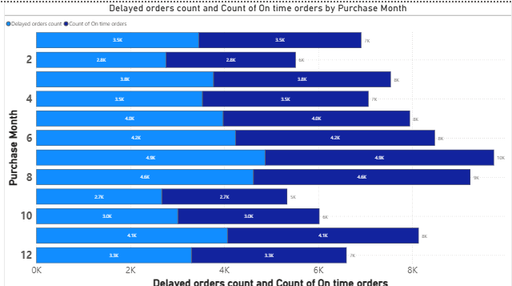

This report analyses the "Delayed orders count and Count of on time orders by Purchase Month" as presented in the provided bar chart.

**Key Observations:**

**Overall Trend:** The graph illustrates the breakdown of order delivery performance (delayed vs. on-time) across different purchase months, ranging from month 2 to month 12.

**On-Time Orders Dominance:** In most months, the count of on-time orders significantly outweighs the count of delayed orders, indicating generally efficient order fulfilment.

**Fluctuations in Order Volume:** The total number of orders (sum of delayed and on-time) varies by month, with month 6 and 8 appearing to have the highest total order volumes.

**Delayed Orders Consistency:** While on-time orders show more variability in count, the delayed orders count appears relatively consistent across months, although specific values are not fully legible for all months.

**Month 12 Performance:** Month 12 shows a substantial volume of both on-time and delayed orders, with on-time orders still forming the larger portion.

**Inferences:** The company generally manages to deliver orders on time, but there's a consistent presence of delayed orders each month.

Months with higher overall order volumes (e.g., months 6 and 8) still maintain a strong proportion of on-time deliveries, suggesting scalability in their on-time fulfilment process, despite the absolute number of delayed orders potentially increasing with volume.

**Q4. Payment type Analysis**

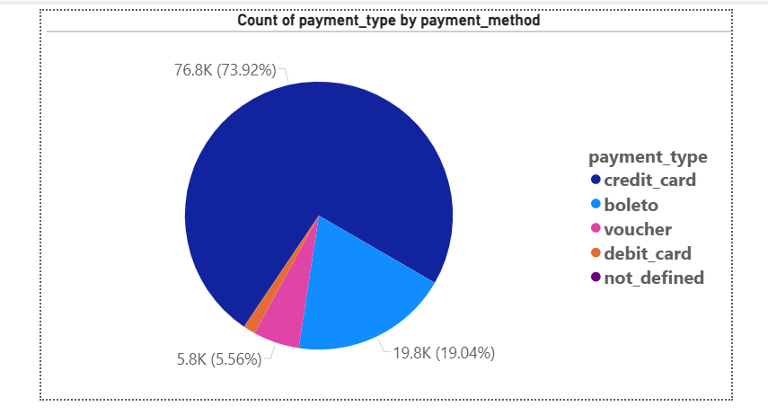This pie chart, titled "Count of payment_type by payment_method," illustrates the distribution of different payment methods based on their usage count.

**Key Observations:**

**Credit Card Dominance:** Credit cards represent the overwhelming majority of payment types, accounting for 76.8K transactions, or 73.92% of the total.

**Debit Card as Second:** Debit cards are the second most frequent payment method, with 19.8K transactions, making up 19.04% of the total.

**Other Methods:** A smaller segment, totaling 5.8K transactions (5.56%), comprises other payment types including 'boleto', 'voucher', and 'not_defined'. This category represents a significantly smaller proportion compared to credit and debit cards.

In summary, credit cards are by far the most used payment method, followed by debit cards, while other methods constitute a minor portion of the payment transactions.

**Q5. Product Rating Analysis**

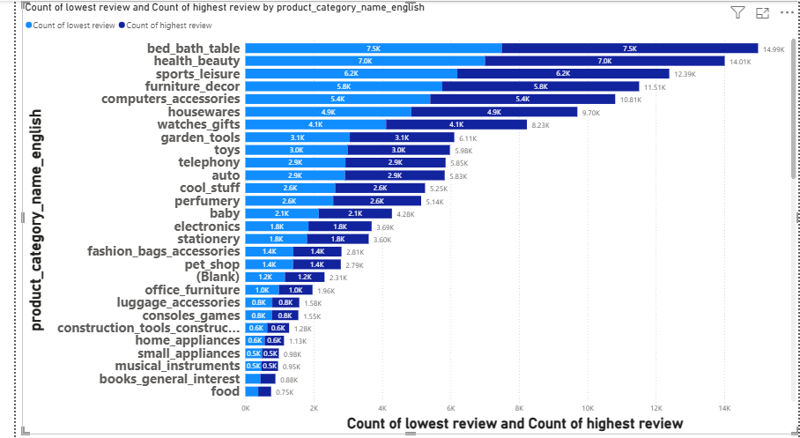

This graph, titled "Count of lowest review and Count of highest review by product_category_name_english," illustrates the distribution of positive and negative reviews across various product categories.

**Key Observations:**

**Highest Review Count:** The categories with the highest number of positive (highest) reviews are: Bed, Bath, Table Health & Beauty Sports & Leisure Furniture & Decor Computers & Accessories

**Lowest Review Count:** The categories with a notable number of lowest reviews include: Bed, Bath, Table (also has a high count of lowest reviews, indicating a wide range of customer experiences) Health & Beauty Sports & Leisure Furniture & Decor Categories with Fewer Reviews: Categories like Musical Instruments, Books (General Interest), and Food appear to have significantly fewer reviews overall compared to the top categories.

**Review Distribution:** For many categories, particularly those with a high overall review volume, there's a visible split between highest and lowest reviews, suggesting a diverse range of customer satisfaction within those product groups. For example, "Bed, Bath, Table" clearly shows both a large number of high and low reviews.

In summary, the report indicates that popular categories like "Bed, Bath, Table" and "Health & Beauty" generate the most customer feedback, both positive and negative, while niche categories receive less overall engagement in terms of reviews.

**Q6. State wise total number of Sales**

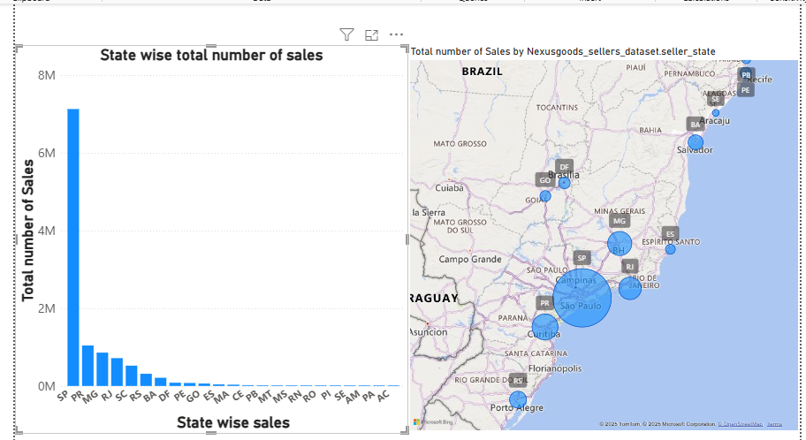This dashboard provides a visual overview of sales performance, specifically focusing on "Total number of Sales" and "State wise total number of Sales" within Brazil, likely related to "Nexusgoods sellers".

**Key insights from the dashboard:**

**Total Sales Overview:** The top bar chart displays the "Total number of Sales," with a scale indicating sales reaching up to 8 million units.

**State-wise Sales Distribution:** The bottom section features a map of Brazil, illustrating "State wise sales" and highlighting various states such as Pernambuco, Tocantins, Bahia, Mato Grosso, Minas Gerais, São Paulo, Espírito Santo, Paraná, Santa Catarina, and Rio Grande do Sul.

**Geographical Sales Concentration:** The size of the circles on the map likely represents the volume of sales in each state, with larger circles indicating higher sales figures (e.g., São Paulo appears to have significant sales based on the large circle).

**Detailed State-wise Sales Breakdown:** The left-hand bar chart, labeled "State wise sales," provides a more granular view of sales performance across different states, identified by their abbreviations (e.g., SP, PR, MG, RJ, SC, RS, BA, GO, PE, ES, MA, CE, PB, MT, MS, RN, RO, PI, SE, AM, PA, AC). This chart allows for a direct comparison of sales volumes between states.

**Interactive Elements:** The presence of a "Zoom selection" option and filter icons suggests that the dashboard is interactive, allowing users to drill down into specific regions or filter the data for more detailed analysis.

**Q7. Seasonal Sales pattern**

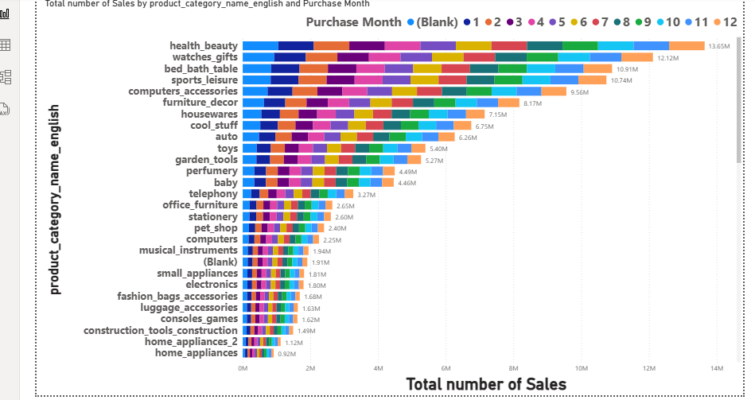This graph, titled "Total number of Sales by product_category_name_english and Purchase Month," displays a breakdown of sales across various product categories, segmented by purchase month.

The horizontal bars represent different product categories, such as "health_beauty," "watches_gifts," "bed bath table," and more specific categories like "musical instruments" or "home_appliances."

Each bar is further divided into segments of different colors, where each color corresponds to a specific purchase month (from 1 to 12).

The length of each colored segment within a bar indicates the total number of sales for that particular product category in that specific month.

The overall length of each bar reflects the total sales for that product category across all months.

The scale at the bottom, labeled "Total number of Sales," provides the quantitative values for these sales figures.

**Q8. Revenue Analysis**

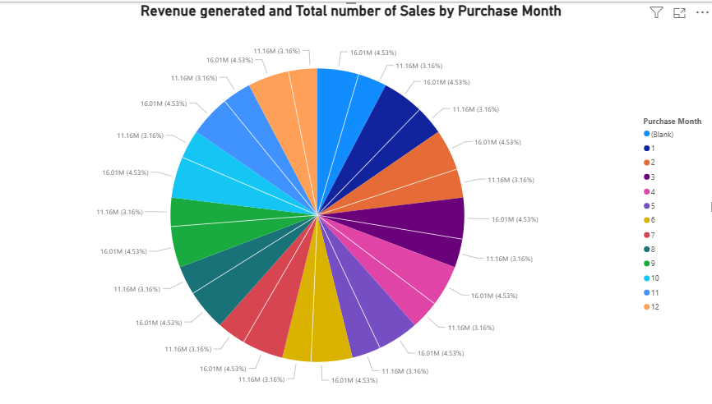This report analyzes the "Revenue generated and Total number of Sales by Purchase Month" as depicted in the provided pie chart.

**Summary of Findings:**

The pie chart illustrates the distribution of revenue and total sales across different purchase months, with each slice representing a specific month and its corresponding revenue amount and percentage of the total.

**Dominant Months:** Several months, particularly those with a revenue of 16.01M, contribute significantly to both revenue and total sales, each accounting for 4.53% of the total.

**Consistent Contributors:** Months generating 11.16M also represent a notable portion, each contributing 2.16% to the overall figures.

**Variations in Contribution:** The chart also shows months with lower revenue figures like 11.36M, representing smaller percentages of the total (e.g., 1.16% or 10%).

**Overall Distribution:** The visualization clearly demonstrates how revenue and sales are distributed throughout the year, highlighting periods of higher and lower performance based on purchase month.

**Conclusion:**

The report provides a clear overview of the revenue and sales performance categorized by purchase month, indicating varying levels of contribution from different periods. Analyzing these monthly contributions can help in understanding sales trends and identifying peak or low-performing months.